In a full fledged web applications, we don't put all our servlet code into one single servlet. We spread our business logic across different servlets, JSPs like that. There should be a mechanism for them to communicate with eachother. This is called Request dispatching.

Uri – indicates the url where we would want to go next/dispatch from this servlet.

Two ways request dispatching can be done :

- forward( ) method -> the complete control can be forwarded to another servlet.

rd.forward(request, response);

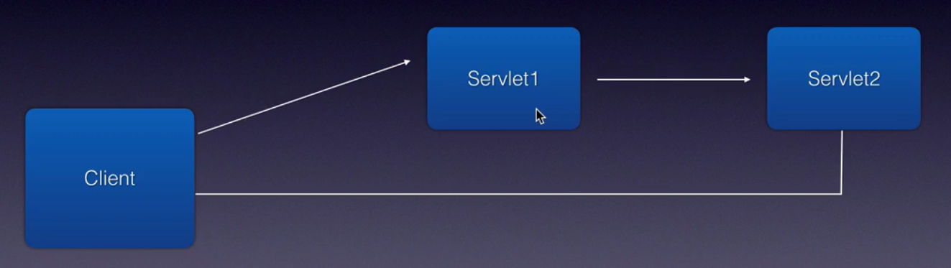

- include( ) method -> the container will merge the response from multiple servlets and sends back the response.

rd.include(request, response)

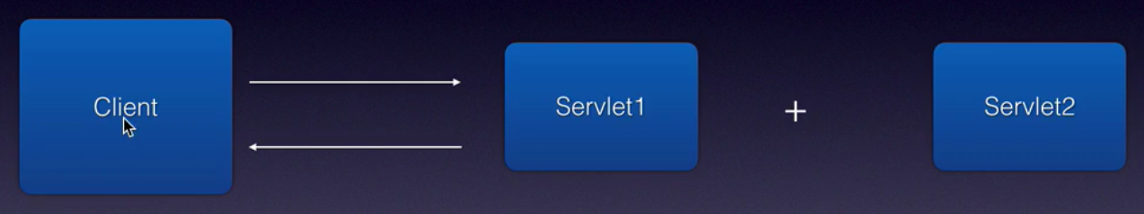

Usecases : login usecase.

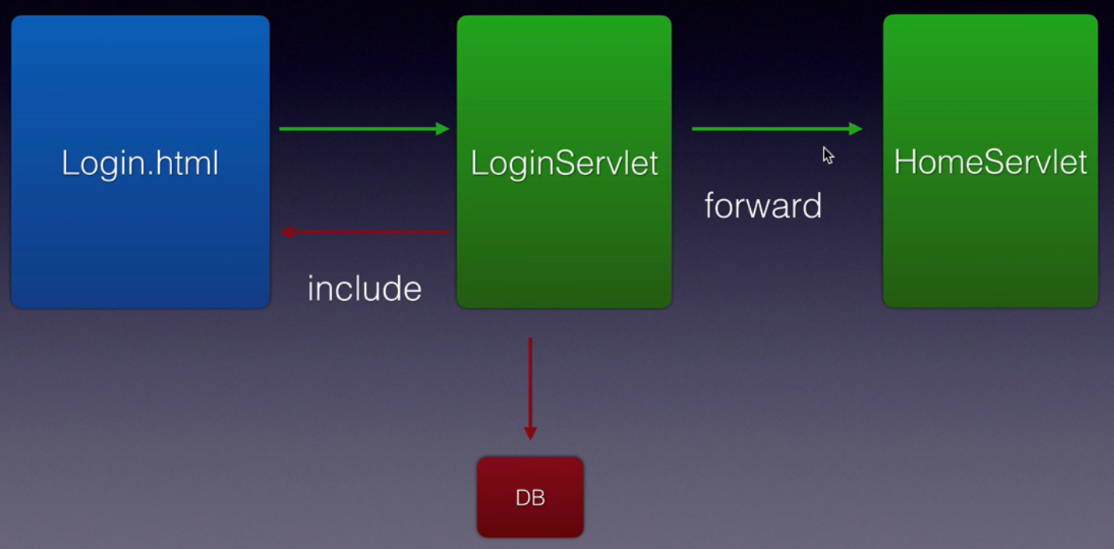

protected void doPost(HttpServletRequest request, HttpServletResponse response)
throws ServletException, IOException {

String userName = request.getParameter("userName");
String password = request.getParameter("password");

try {
Class.forName("com.mysql.jdbc.Driver");
Connection conn = DriverManager.getConnection(
"jdbc:mysql://localhost/mylocaldb", "root", "chotu123");
Statement stmt = conn.createStatement();

ResultSet rs = stmt.executeQuery("select * from user where
email = '" + userName + "' and password = '" + password + "'");

RequestDispatcher requestDispatcher = request.getRequestDispatcher(
"homeServlet");
if(rs.next()){
// login success case
request.setAttribute("mesg", "Welcome Mr." + userName);
requestDispatcher.forward(request, response);
} else {
// login failure case
requestDispatcher = request.getRequestDispatcher("login.html");
requestDispatcher.include(request, response);
}

} catch (ClassNotFoundException e) {
e.printStackTrace();
} catch (SQLException e) {
e.printStackTrace();
}
}

What is a RequestDispatcher? What object do you use to forward a request?

A Servlet can obtain its RequestDispatcher object from its ServletContext or from ServletRequest.

What is the difference between the getRequestDispatcher(String path) method of “ServletRequest” interface and ServletContext interface?

javax.servlet.ServletRequest.getRequestDispatcher(String path) accepts path parameter of the servlet or JSP to be included or forwarded relative to the request of the calling servlet. If the path begins with a “/” then it is interpreted as relative to current context root.

javax.servlet.ServletContext.getRequestDispatcher(String path) does not accept relative paths and all path must start with a “/” and are interpreted as relative to current context root.

Q. What is the difference between forwarding a request and redirecting a request?

Both methods send you to a new resource like Servlet, JSP etc, but there is a key difference.

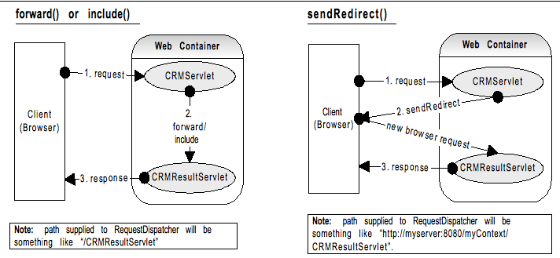

Forward action takes place within the server without the knowledge of the browser.
Accepts relative path to the servlet or context root. So, there is no extra network trip.

sendRedirect sends a header back to the browser, which contains the name of the resource to be redirected to. The browser will make a fresh request from this header information. Need to provide absolute URL path. This has an overhead of extra remote trip but has the advantage of being able to refer to any resource on the same or different domain and also allows book marking of the page.

